Principal Component Analysis

Principal Component Analysis is an unsupervised dimensionality reduction technique used to transform high dimensional data into a lower dimensional space while retaining maximum variance. PCA works by identifying new orthogonal axes called principal components that capture the directions of maximum variance in the data. These components are ordered such that the first principal component captures the highest variance, followed by subsequent components capturing decreasing amounts of variance.
The steps involved in PCA are:
- Standardize the dataset so that all features have zero mean and unit variance
- Compute the covariance matrix of the standardized data
- Calculate eigenvalues and eigenvectors of the covariance matrix
- Sort the eigenvectors in descending order of eigenvalues
- Select the top principal components based on explained variance
Project the original data onto the selected components
Example of PCA
Consider a dataset with two correlated features. Instead of using both features, PCA identifies a new axis along which the variance is maximum. Projecting the data onto this axis reduces the dimensionality from two to one while retaining most of the information.
Explained Variance
Explained variance represents the proportion of the total dataset variance captured by each principal component. It is computed as the ratio of an individual eigenvalue to the sum of all eigenvalues. The cumulative explained variance is used to determine how many components are required to retain a desired amount of information, commonly 90 percent or 95 percent.

Inference from Experimental Results
In the Iris dataset, PCA reduced four features to two principal components while retaining approximately 95 percent of the total variance. However, classification accuracy decreased slightly because the dataset was already low dimensional and well separated.
In the Breast Cancer dataset, PCA reduced the original 30 features to four principal components while retaining approximately 79 percent of the total variance. Despite significant dimensionality reduction, the classification accuracy remained unchanged compared to the model trained on the original dataset. This indicates that most of the relevant discriminatory information is contained within the first few principal components and that PCA effectively removes redundant and correlated features without degrading model performance.indicating that the essential discriminative information was preserved in the leading components.
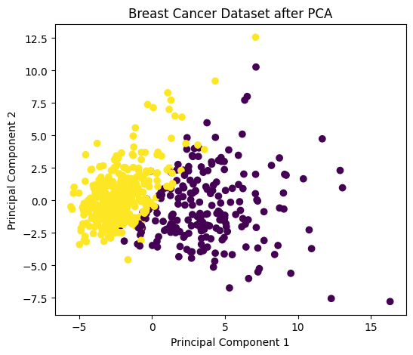

Conclusion
The results demonstrate that PCA is highly effective for high-dimensional datasets, where it reduces feature space complexity while preserving classification accuracy. However, for low-dimensional datasets, PCA may not improve predictive performance and is primarily useful for visualization and exploratory analysis. The choice of the number of principal components plays a crucial role in balancing dimensionality reduction and information retention.

